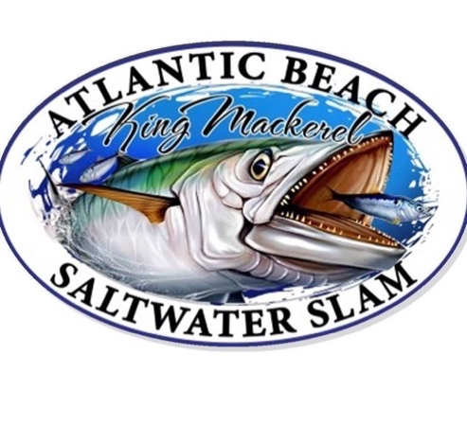
Captains Meeting October, 5th at Crow’s Nest @ 6:00PM
After Party/Pig Pickin’ at the Tipsy Turtle Tavern
Fishing Dates: October 5th – 26th , 2019 @ 2:00 PM
Sponsor and Fisherman Appreciation Event at Crow’s Nest: October 19th @ 7:00PM
Awards Banquet at Crow’s Nest October 26th @ 6:00 PM

THE Title Sponsor:  $20,000  Name included in the title of the event  Name/Logo printed on all marketing/advertising/promotions/website/radio ads  Name/Logo prominently displayed on back of T-shirt Name on sign at the Circle  12 T-shirts, 12 Hats, 12 tickets to Appreciation Event  2 “Official Sponsor” Posters  4 Entries into the Tournament | Exclusive Anchor Event Sponsor $15,000  Name/Logo printed on all marketing/advertising/promotions/website/radio ads  Name/Logo prominently displayed on back of T-shirt Name on sign at the Circle  10 T-shirts, 10 Hats, 10 tickets to Appreciation Event  2 “Official Sponsor” Posters  4 Entries into the Tournament
Platinum Sponsor: $5000  Name/Logo printed on all marketing/advertising/promotions/website/radio ads.  Name/Logo prominently displayed on back of T-shirt; Name on sign at the Circle  8 T-shirts, 8 Hats, 8 tickets to Appreciation Event  2 “Official Sponsor” Posters  2 Entries into the Tournament | Gold Sponsor: $1,000  Logo on T-shirt  Name/Logo on Website  Name on message board at the Circle  6 T-shirts, 6 Hats, 6 tickets to Appreciation Event  1 “Official Sponsor” Poster  1 Entry into the Tournament
Silver Sponsor: $500  Name on t-shirt  Name/Logo on Website  Name on message board at the Circle  4 T-shirts, 4 Hats, 4 tickets to Appreciation Event  1 “Official Sponsor” Poster | Bronze Sponsor: $250  Name/Logo on Website  2 T-shirts, 2 Hats, 2 tickets to Appreciation Event  1 “Official Sponsor” Poster

Sponsorship Opportunities:
Business/Name (as you want it displayed on advertising):

___________________________________________________________

Address: City / St /Zip: _________________________________________

ContactName:________________________ Phone:_________________

E-mail: ____________________________________________________

Sponsorship Level:

- $20,000 (12 shirts/hats)
- $15,000 (10 shirts/hats)
- $5,000 (8 shirts/hats)
- $1000 (6 shirts/hats)
- $500 (4 shirts/hats)
- $250 (2 shirts/hats)

Please note the size and sleeve length for the t-shirts you will receive based on your sponsor level (adult sizes only):

 | Small | Medium | Large | XL | XXL | XXXL
Short Sleeve
Long Sleeve

Checks should be made payable to: ABKMT, Inc.

PO Box 1074, Atlantic Beach, NC 28512

